# Password Generator

# Design: UML Diagrams

## **Use case diagram**

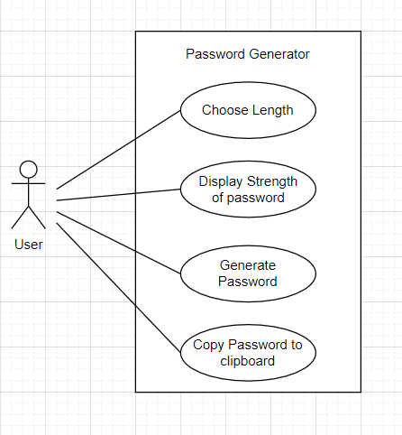

Fig.1. Use case Diagram

## **Class diagram**

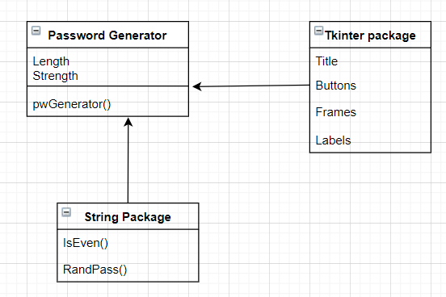

Fig.2. Class Diagram